Download and Install Git

Download Git
# Source: ScreenShots Source: Provided by: [Persons Table -> ID Column: 1, Name_En Column: Motasem Essam] -> Tool: [Lightshot Program] -> From [Site: Google Search: All: Git] on [2/16/2026]
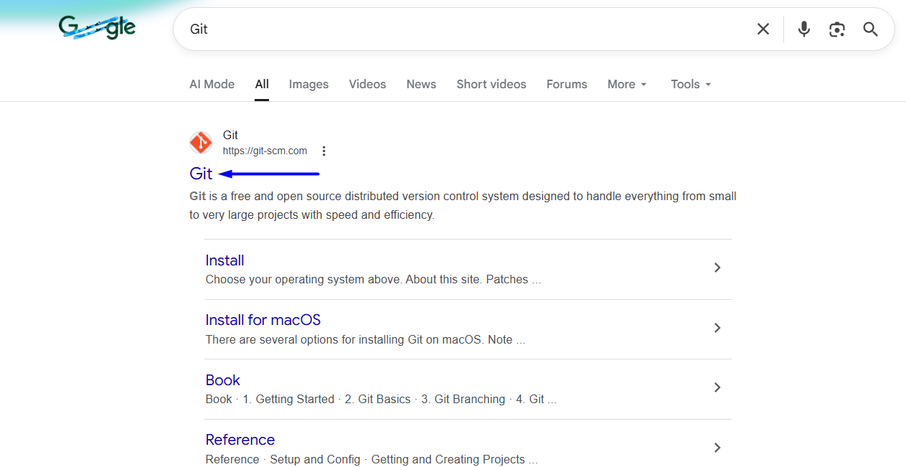
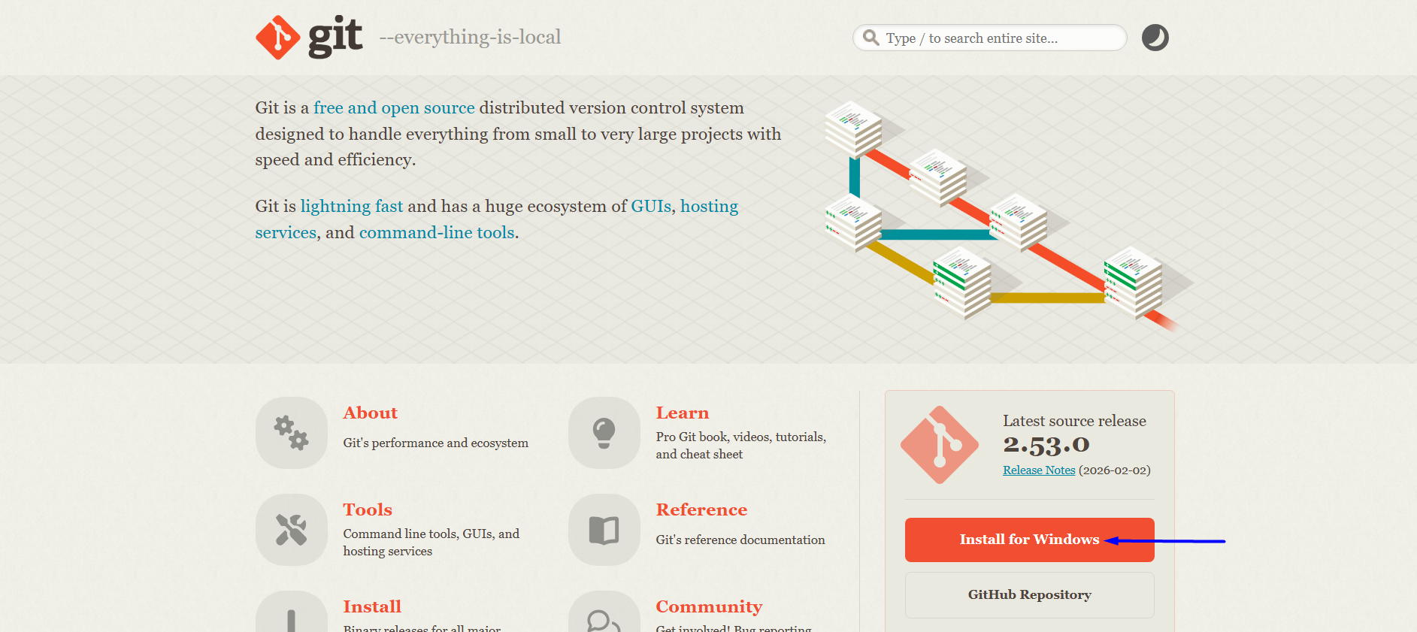
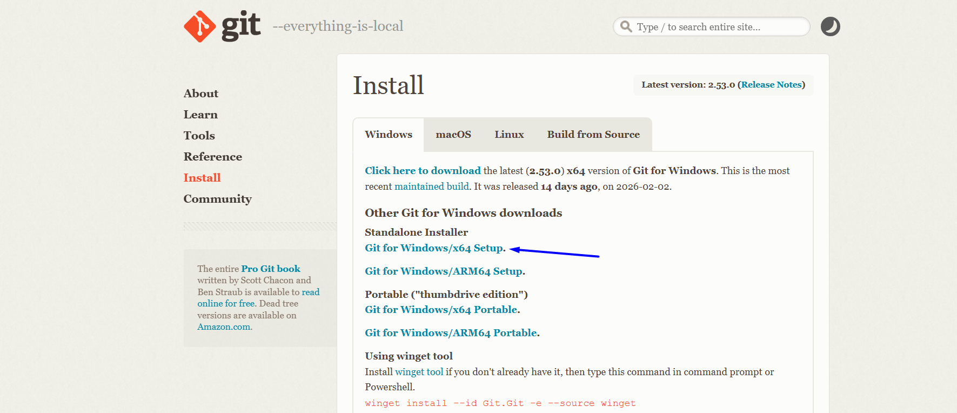
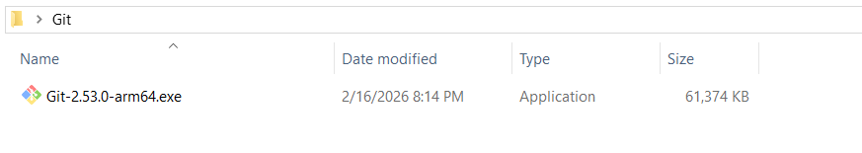

Install Git
# Source: ScreenShots Source: Provided by: [Persons Table -> ID Column: 1, Name_En Column: Motasem Essam] -> Tool: [Lightshot Program] -> From [Windows] on [2/16/2026]
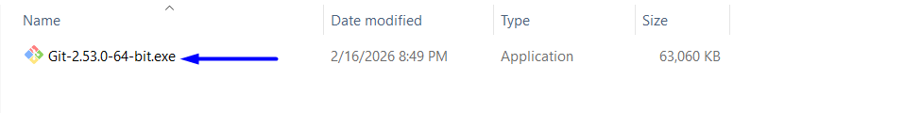

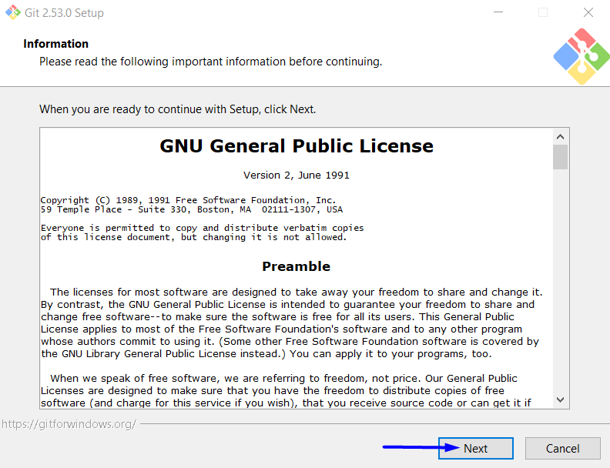
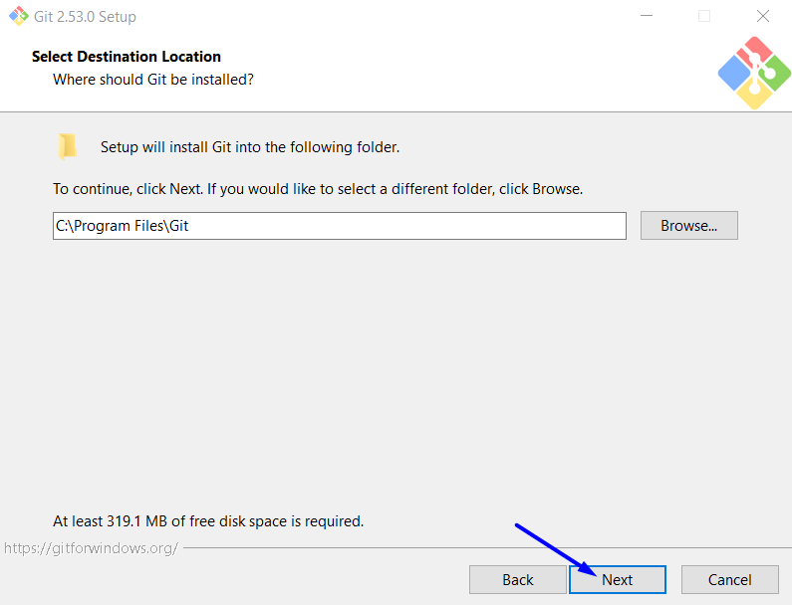
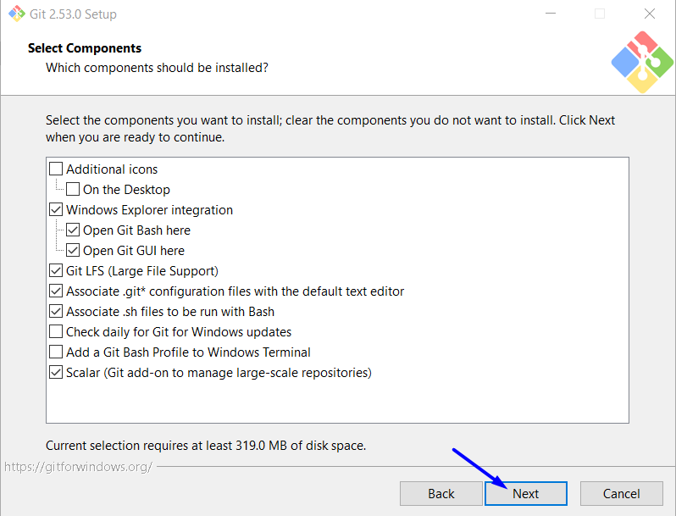
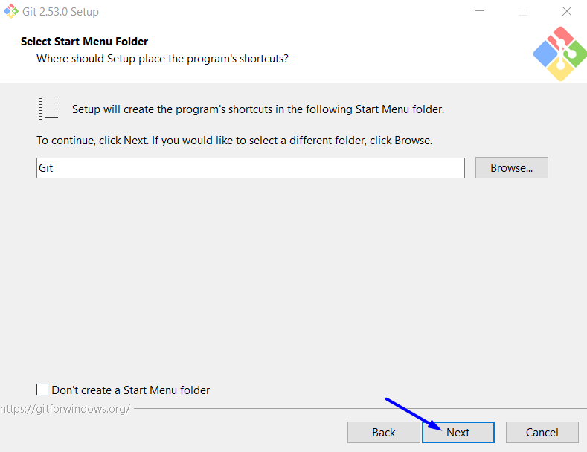
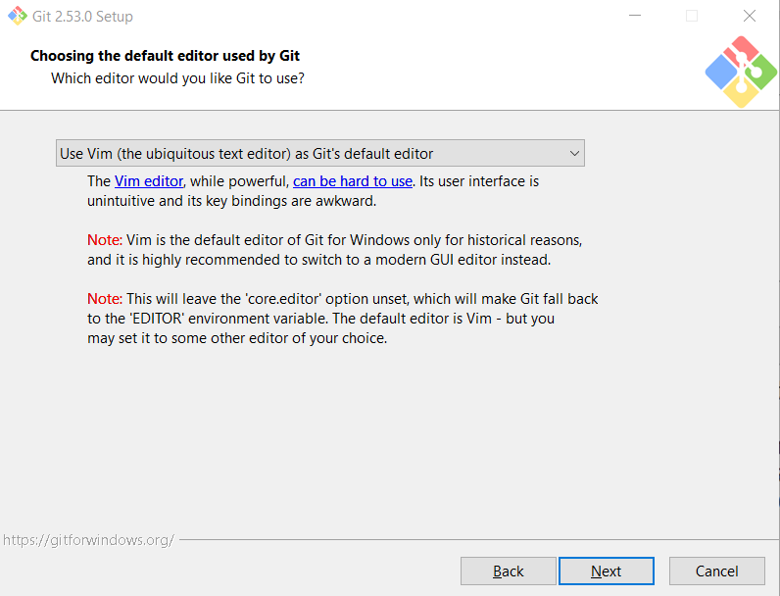
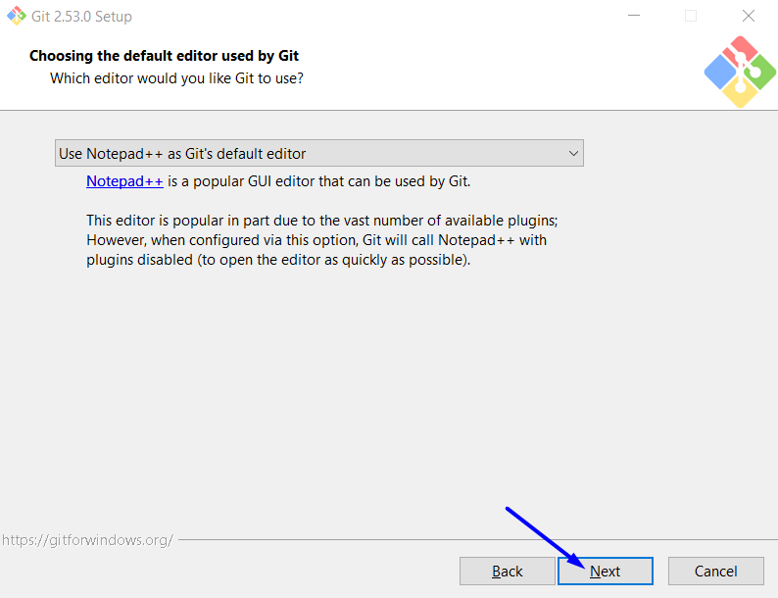
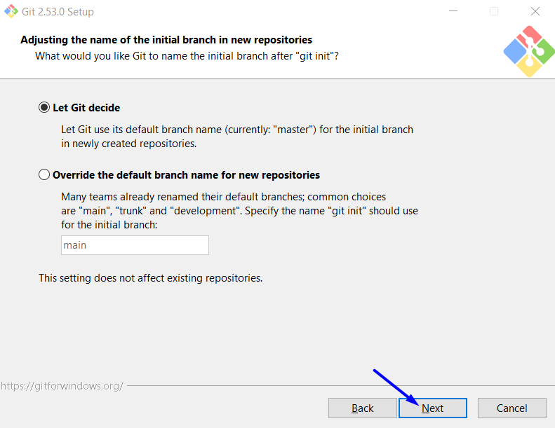
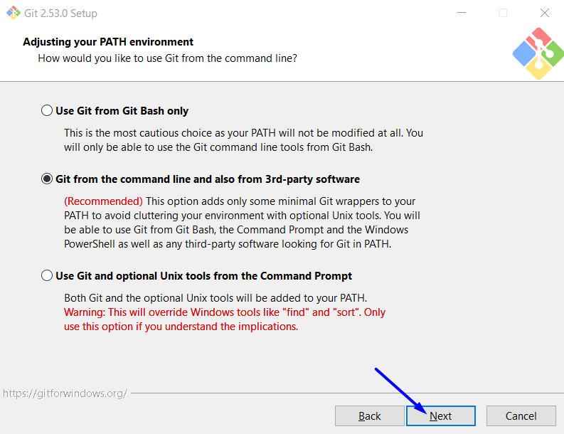
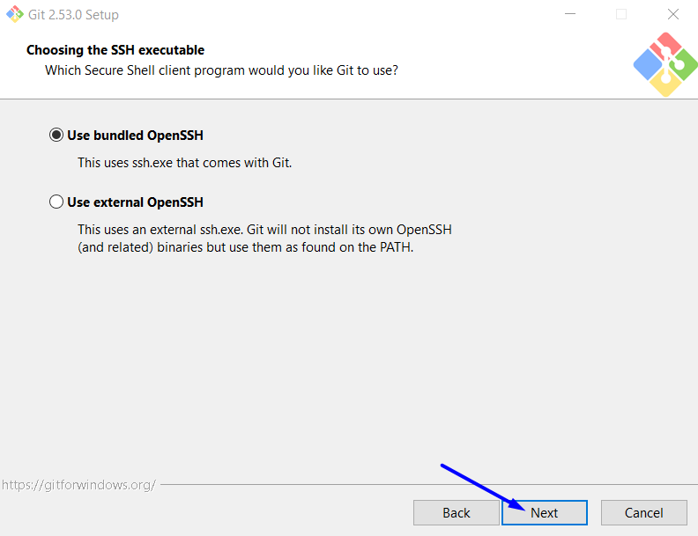
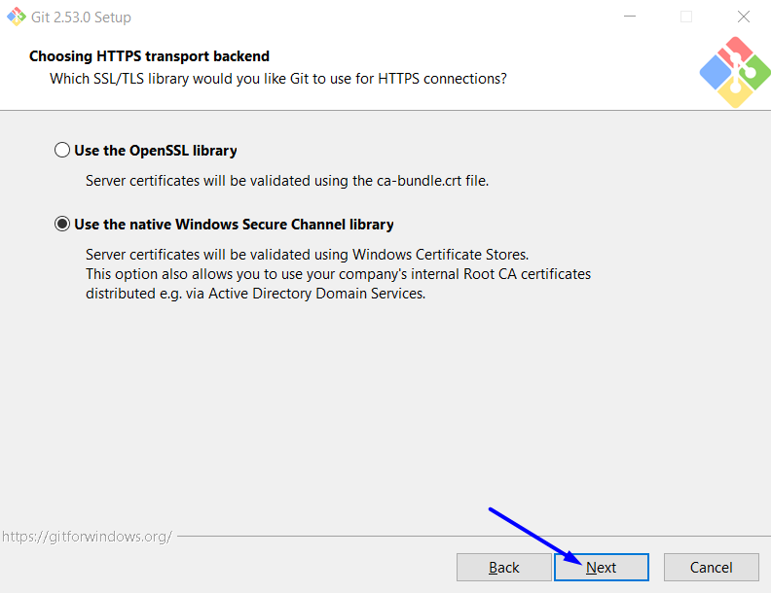
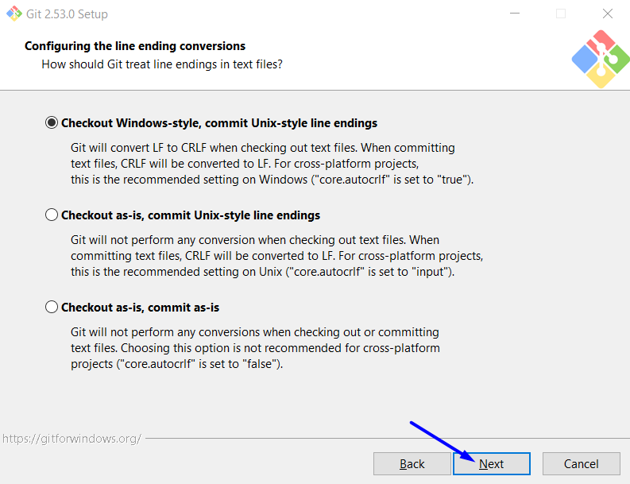

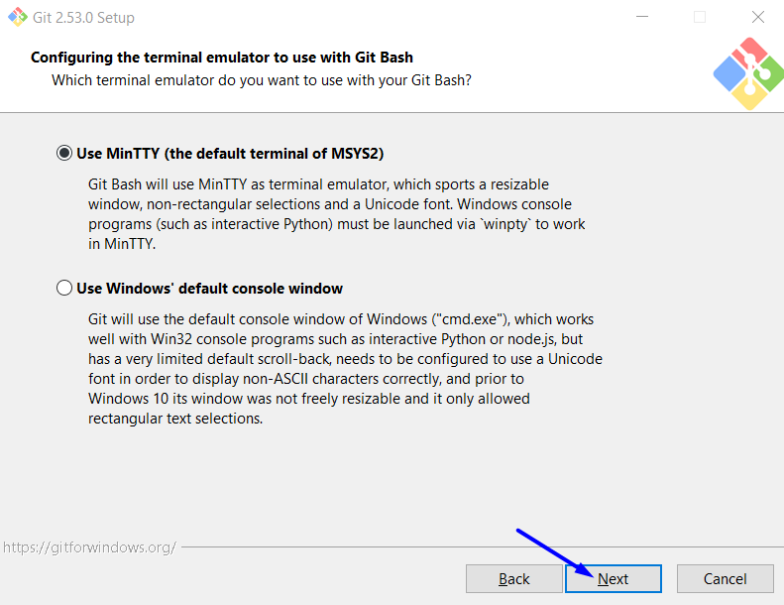
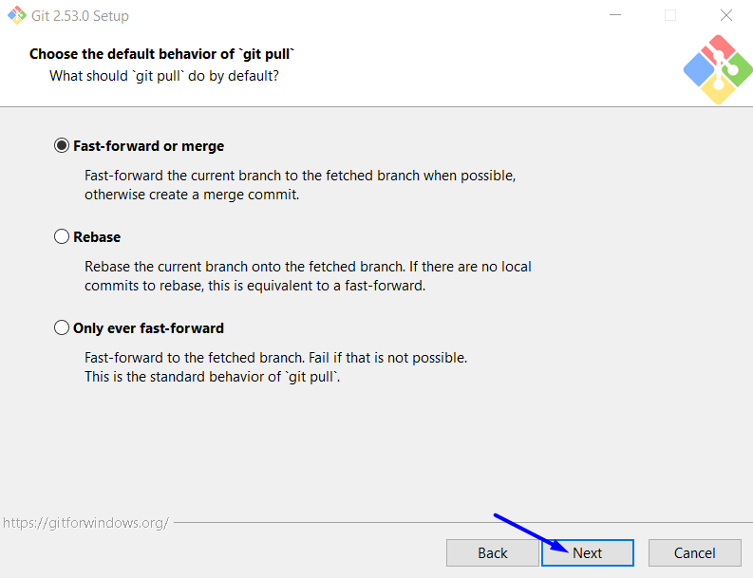
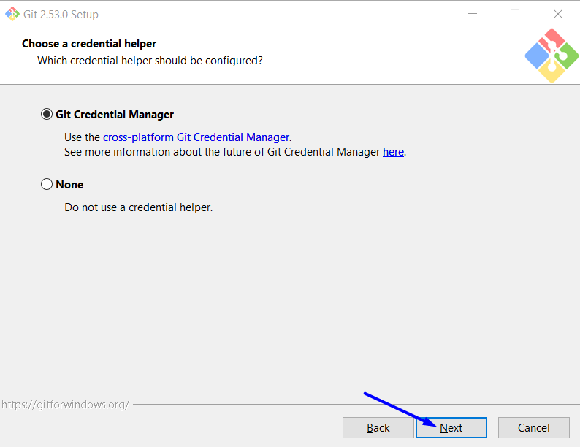
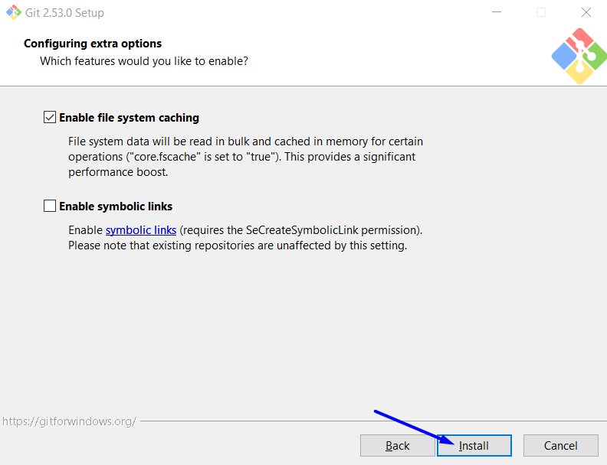
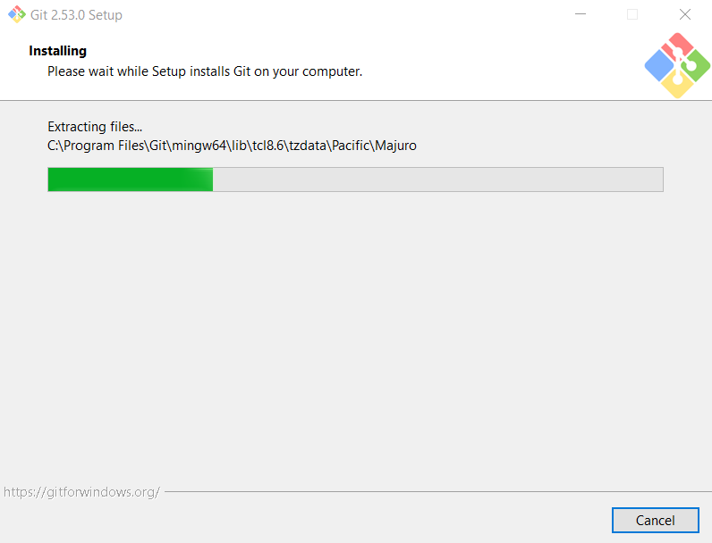
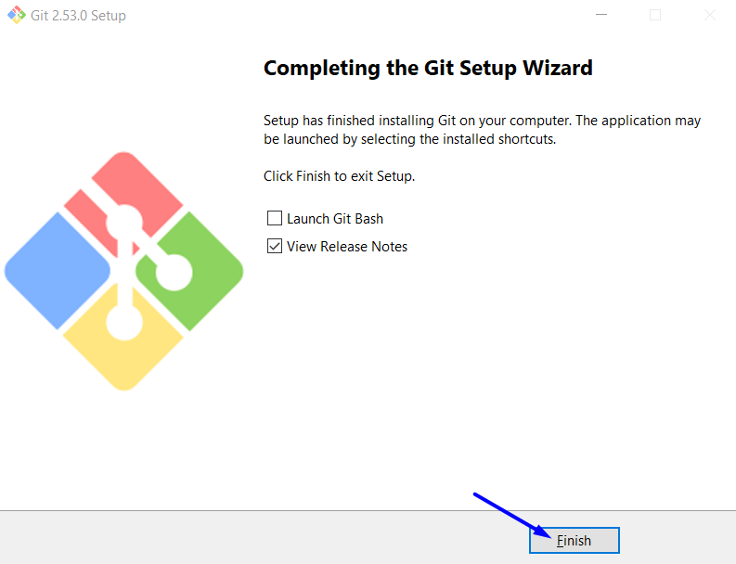

Run Git Bash
# Source: ScreenShots Source: Provided by: [Persons Table -> ID Column: 1, Name_En Column: Motasem Essam] -> Tool: [Lightshot Program] -> From [Windows] on [2/16/2026]
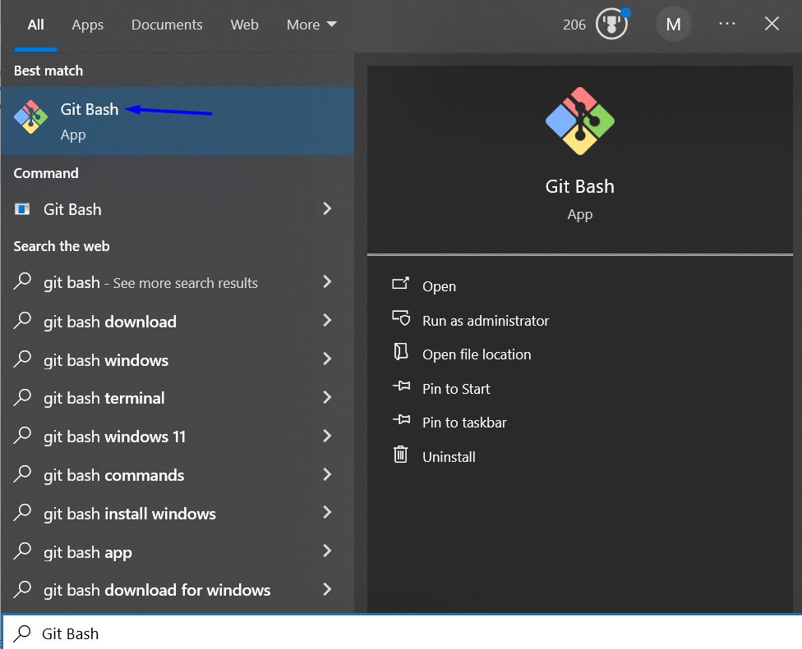
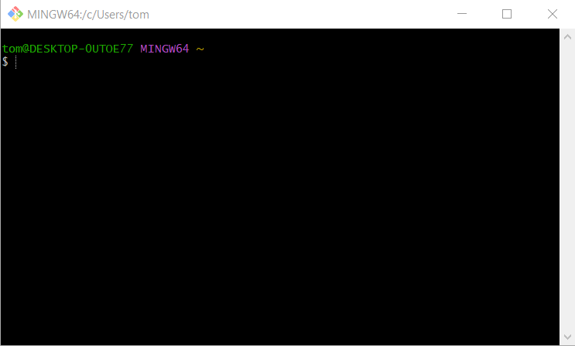
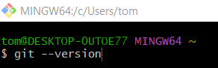
git --version
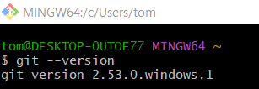

Run Git GUI
# Source: ScreenShots Source: Provided by: [Persons Table -> ID Column: 1, Name_En Column: Motasem Essam] -> Tool: [Lightshot Program] -> From [Windows] on [2/16/2026]
